**ETL Program to Azure Cosmos DB and Azure Storage BLOBS**

Cary Grant Anderson

2/2019

1. **ETL:**
   1. First Generation ETL Program – Command line program in C# to retrieve data from Cosmos DB NoSQL databases, transform the data to a relational form, and insert it into SQL Server for cubing and reporting.
      1. Main Points:
         1. Simple and effective ETL via a command line program.

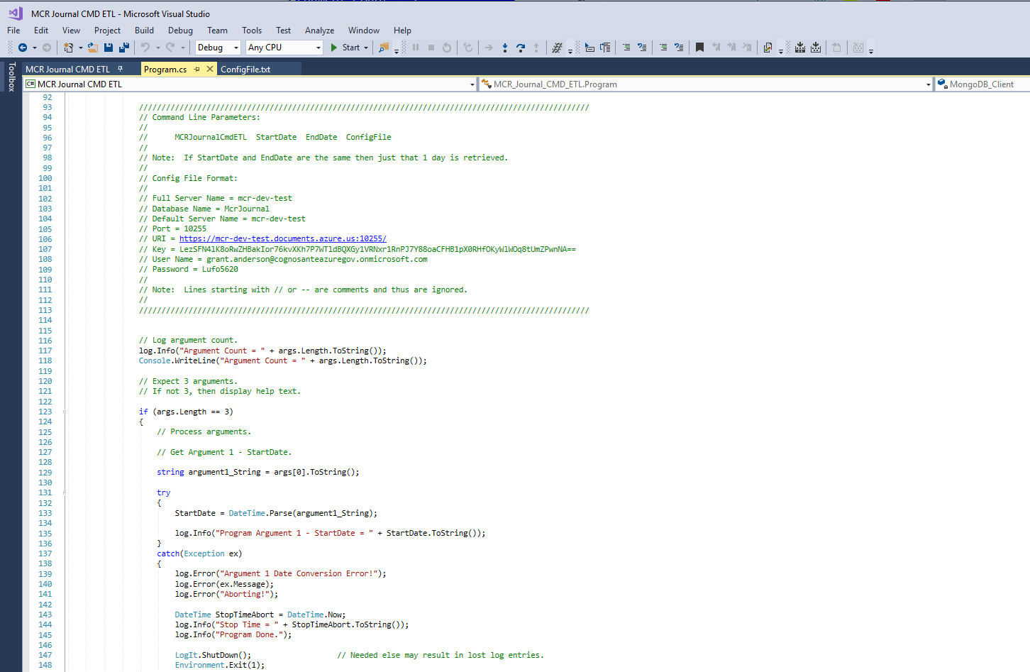

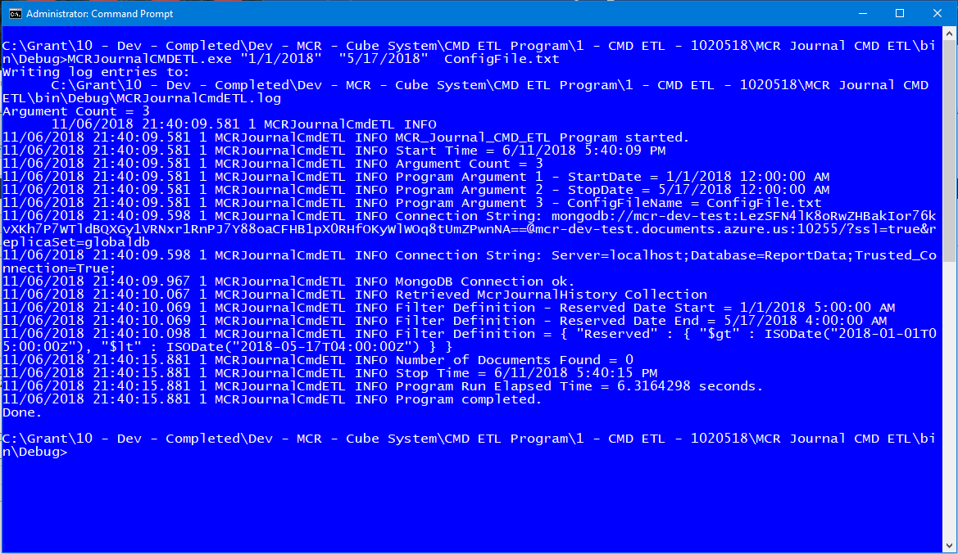

* 1. Second Generation ETL Program – Command line program in C# to create a Universal ETL Program for NoSQL to relational data transfer and ETL.
     1. Main Points:
        1. Auto adapting ETL program.
        2. Uses Definition Programming for operations instead of endless code changes to adapt to various ETL scenarios and operations.
        3. Can be expanded into a full universal ETL program that can replace a large number of SQL and SSIS ETL implementations.
        4. Fast Evolution (a Super Agile principle/practice) over the first-generation program.

